Please mark your paper type here (Original research paper/Reviews)
Title should be concise and informative and avoid abbreviations and formulae where possible

ABDEL-ATY M^{1,}*, TETER J^{2, 3}
(1. Department of Civil, Environmental and Construction Engineering, University of Central Florida, Orlando FL32816, Florida, USA
2. Institute of Transportation Studies, UC Davis, Davis CA95616, California, USA;
3. Department of Civil and Environmental Engineering, New Jersey Institute of Technology, Newark NJ07102, New Jersey, USA)

Abstract: The abstract should state the purpose, method, principal results and major conclusions of your work. Besides, more important thing is to show the highlights of your paper in abstract. Not too short, you should give 200-300 words in abstract part. References should be avoided, non-standard or uncommon abbreviations should be avoided, but if essential they must be defined at their first mention in the abstract itself.

Key words: traffic safety; transportation safety planning; (method); (research subject / object);….（4-6 words）

稿件中文题目（Title in Chinese）
稿件中文摘要/关键词（Abstract & key words in Chinese）
*Corresponding author. Tel: +1-222-333-4444, Fax: +1-222-333-4444 (if have).

Author resume: full name, gender, professor, PhD advisor, PhD, E-mail: m.aty@ucf.edu.
- 0 Introduction
These instructions give you basic guidelines for preparing papers for JTTE. Your goal is to simulate the usual appearance of papers follow this format. Remember your submission should be offered in both “MS WORD” and PDF format. Prepare your paper in full-size format on A4 paper, with line number and double space between lines (as this template shows). Manuscript may be around 5000 words or longer.
The manuscript should be original, and has not been published previously. Do not submit material that is currently being considered by another journal.
In introduction part, provide an adequate background and state the objectives of the work.
1.1 Math formulae
Present simple formulae in the line of normal text where possible and use the solidus (/) instead of a horizontal line for small fractional terms, e.g., X/Y. In principle, variables are to be presented in italics. Powers of e are often more conveniently denoted by exp. Number consecutively any equations that have to be displayed separately from the text (if referred to explicitly in the text).
A comma is used as a thousand separator, e.g. “10,581”, “6,293,470”
- 1 Materials and methods
In ‘materials and methods’ part, provide sufficient detail to allow the work to be reproduced. Methods already published should be indicated by a reference: only relevant modifications should be described.
If there is a theory or calculation in this part, the theory section should extend, not repeat, the background to the article already dealt with in the Introduction, and lay the foundation for further work. In contrast, a calculation section represents a practical development from a theoretical basis.
1.1 Figures and tables
Ensure that each figure and table has a caption both in English and Chinese (not on the figure or table itself). Figure captions should be centered below the figures; table captions should be centered above. If you have sub-figures, make sure each sub-figure has one caption. Keep text in the figures themselves to a minimum but explain all symbols and abbreviations used in text.
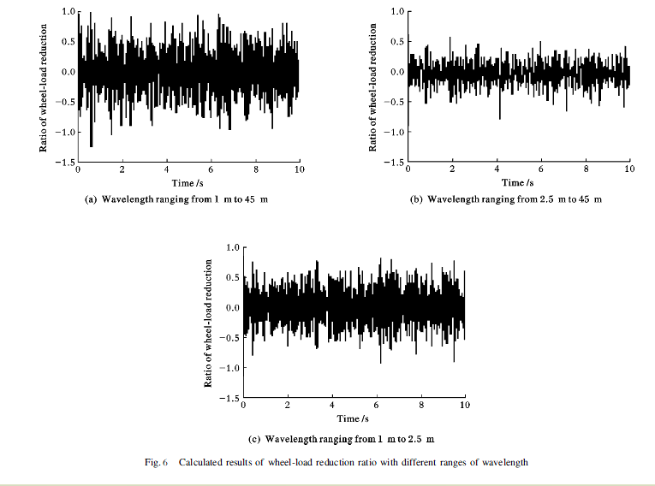
Fig. 1 The title of the figure
图1 中文图名（Figure title in Chinese）
Avoid placing figures and tables before their first mention in the text. In text and figure legend, “Fig. #” is used for figure and “Table #” is used for table, for examples: “Table 1 Demographic characteristics of patients” and “Fig. 1 Coronary angiography shows no significant in-stent stenosis”.
Regardless of the application used, when your electronic artwork is finalized, please "save as" or convert the images to one of the following formats (note the resolution requirements for line drawings, halftones, and line/halftone combinations given below):
EPS: Vector drawings. Embed the font or save the text as "graphics".
TIFF: color or grayscale photographs (halftones): always use a minimum of 300 dpi.
TIFF: Bitmapped line drawings: use a minimum of 1000 dpi.
TIFF: Combinations bitmapped line/half-tone (color or grayscale): a minimum of 500 dpi is required.
If your electronic artwork is created in a Microsoft Office application (Word, PowerPoint, Excel) then please supply "as is".
Please do not:
• Supply files that are optimised for screen use (like GIF, BMP, PICT, WPG); the resolution is too low;
• Supply files that are too low in resolution;
• Submit graphics that are disproportionately large for the content.
1.2 References
Cite references in the text by the order of sequence (NOT by name and year). Some examples:
As demonstrated by Allan et al^{[1-2]}…..
Kramer ^{[3]} has recently shown....
The detail result can be found in the reference [4].
According to the safety fact^{[5]}, we can …..
Reference list entries should be in accordance with the order number in the text.
1.3 Abbreviations and acronyms
Define abbreviations and acronyms the first time they are used in the text, even if they have been defined in the abstract. Do not use abbreviations in the title unless they are unavoidable.
1.4 Equations
Number equations consecutively with equation numbers in parentheses flush with the right margin, as in Eq.(1)
a + b = c (1)
where a is…, b is….
Symbols in your equation should be defined before the equation appears or immediately following. Use “Eq. (1)” to quote the equation, except at the beginning of sentence: “Equation (1) is…”. Make sure all the variables in the equations should have clear definitions.
- 2 Results and discussion
Results and discussion can be separated into two part or appear in one part in your manuscript.
Discussion part should explore the significance of the results of the work, not repeat them. A combined Results and Discussion section is often appropriate. Avoid extensive citations and discussion of published literature.
- 3 Conclusions
In conclusions, there should not be any references or results from reference. Only the conclusion from your own results can appear here.
The main conclusions of the study may be presented in a short Conclusions section, which may stand alone or form a subsection of a Discussion or Results and Discussion section.
Acknowledgments
If your work is supported by some projects, named them here. Persons and institutes needed to thank also put them here.
References (no less than 25 references)
Examples:
Journal articles:
- ELANDER J,WEST R,FRENCH D. Behavioral Correlates of Individual Differences in Road-traffic Crash Risk: An Examination of Methods and Findings[J].Psychological Bulletin,1993,113(2):279-294.
- RANNEY T A. Models of Driving Behavior: A Review of Their Evolution[J].Accident Analysis & Prevention,1994,26(6):733-750.
- SIMONS-MORTON B G,GUO F,KLAUER S G, et al. Keep Your Eyes on the Road: Young Driver Crash Risk Increases According to Duration of Distraction[J].Journal of Adolescent Health,2014,54(S5):S61-S67.
- ZHANG H,SMITH M R H,WITT G J. Identification of Real-time Diagnostic Measures of Visual Distraction with an Automatic Eye-tracking System[J].Human Factors: The Journal of the Human Factors and Ergonomics Society,2006,48(4):805-821.
Book with edition & book chapter:
- LUCKIESH M, MOSS F. Light, Vision and Seeing: A Simplified Presentation of Their Relationships and Their Importance in Human Efficiency and Welfare[M]. 2nd ed. New York: D. Van Nostrand Company,1994.
- JACOB R J K,KARN K S. Eye Tracking in Human-computer Interaction and Usability Research: Ready to Deliver the Promises[M] //RADACH R,HYONA J,DEUBEL H. The Mind's Eye: Cognitive and Applied Aspects of Eye Movement Research. Amsterdam: Elsevier Science,2003:573-605.
Conference proceedings:
- DU Z,HUANG F,PAN X. Analysis on Fixation Distribution Characteristics of Drivers in Long Freeway Tunnels[C] //YAN X,YI P,ZHU D, et al. Proceedings of ICTIS 2013:Improving Multimodal Transportation Systems—Information, Safety, and Integration.Reston:ASCE,2013: 1251-1261.
- NEALE V L, DINGUS T A, KLAUER S G, et al. An Overview of the 100-Car Naturalistic Study and Findings[C] //GILMORE D E. Proceedings of the 19th International Technical Conference on the Enhanced Safety of Vehicles. Washington DC: NHTSA, 2005:1-10.
Thesis:
- LIANG Y. Detecting Driver Distraction[D].Iowa City: The University of Iowa,2009.
Website:
- Washington University. Warning System for Fatigued Drivers Nearing Reality with New Eye Data[EB/OL].( Publish date: 1999-07-27)[ Date accessed: 2014-06-29]. http://www.sciencedaily.com /releases /1999/ 07/990727072510.htm.
Technical Report:
- DINGES D F,MALLIS M M,MAISLIN G, et al. Evaluation of Techniques for Ocular Measurement as an Index of Fatigue and the Basis for Alertness Management[R].Washington DC: Federal Highway Administration,1998.
- LIAO Y S,WENG M C,CHEN C T. Design and Implementation of an Image-based Driver Attention Warning System on Low-cost DSP Platform[J].SAE Paper 2010-01-0713.

Besides, do not forget to add detailed author information of degree, professional title (Professor? Associate Professor? Lecturer? PhD Candidate? Engineer?), research fields, email address, complete postal address, and phone number (and Fax number, if have) at the end of your submission for further contacting. Contact details must be kept up to date.

For a quick review process, you can suggest 3 possible reviewers who are familiar with the manuscript for reference. Please offer the information of their Email addresses, affiliations, and research fields.

(Last updated in November 2, 2015)

页面布局

页边距：上下2.54cm,左右2.2cm。
页眉：首页不加页眉，其他页页眉都加横线，奇数页论文题目，偶数页统一为“青研论坛”，字体宋体小四，居中对齐。
注意：（1）段前段后距离
（2）字体是否加粗
（3）引言标号从0开始
（4）各级标题字体不同，是否加粗等

